Database System Engineering and Distributed Backend Development
Course Code: 25CS13002E
ROLL NO:2520030527
NAME: K.Vansika Reddy
BANK DATABASE – TRIGGERS AND STORED PROCEDURES

Query 1: CREATE DATABASE
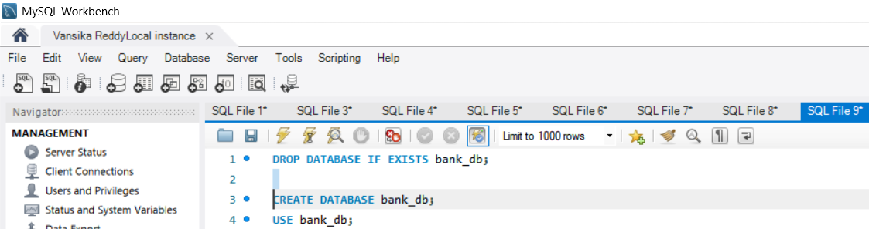

Output:
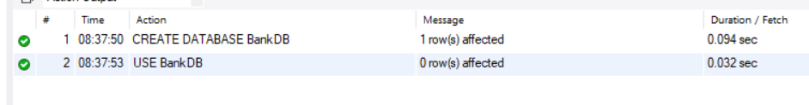
Query 2: CREATE CUSTOMER TABLE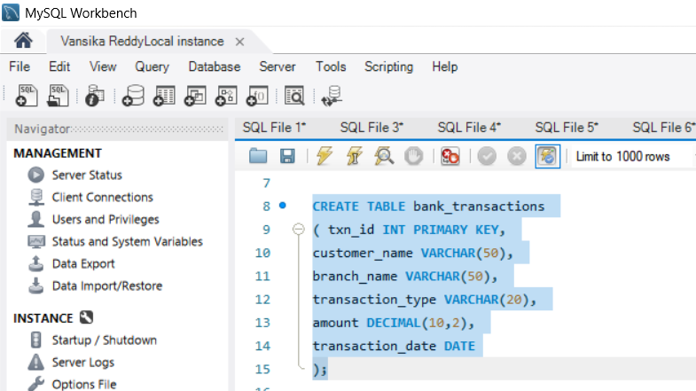
Output:

Query 3: CREATE ACCOUNT TABLE
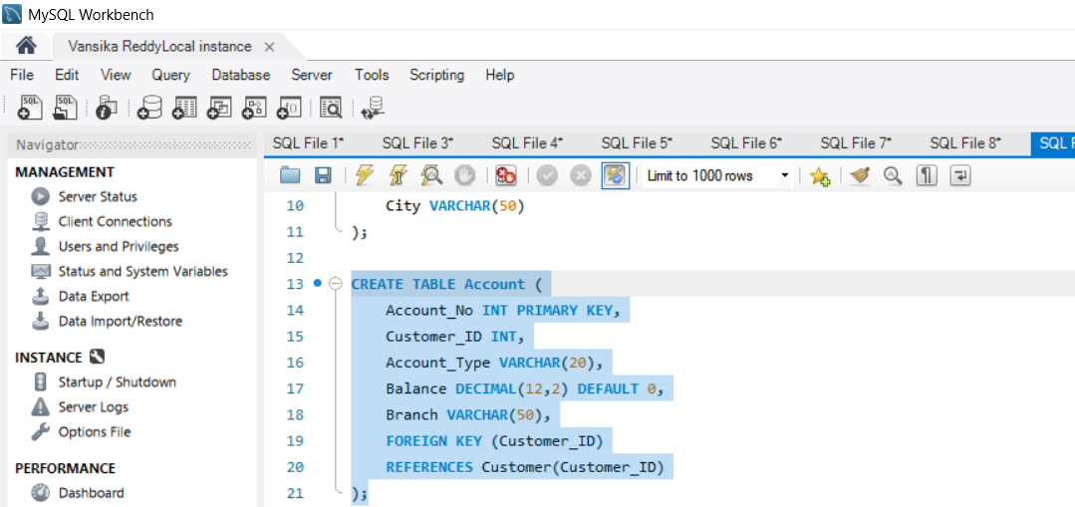

Output:

Query 4: CREATE TRANSACTION TABLE
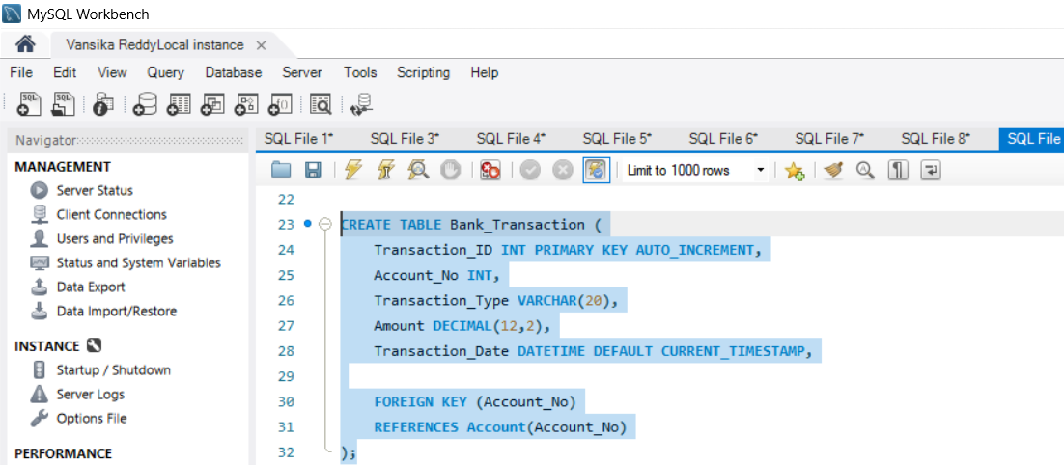
Output:
Query 5: CREATE LOAN TABLE
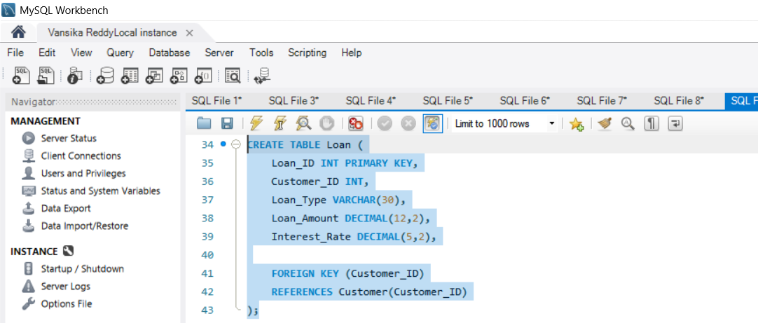

Output:

Query 6: INSERT CUSTOMER DATA
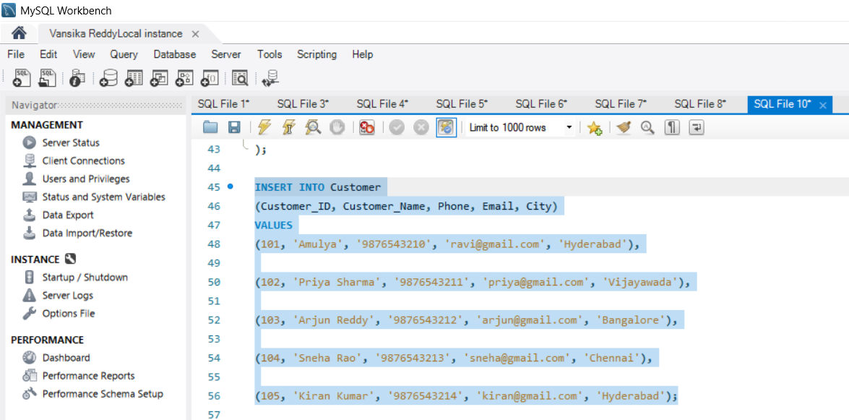

Output:

Query 7: INSERT ACCOUNT DATA
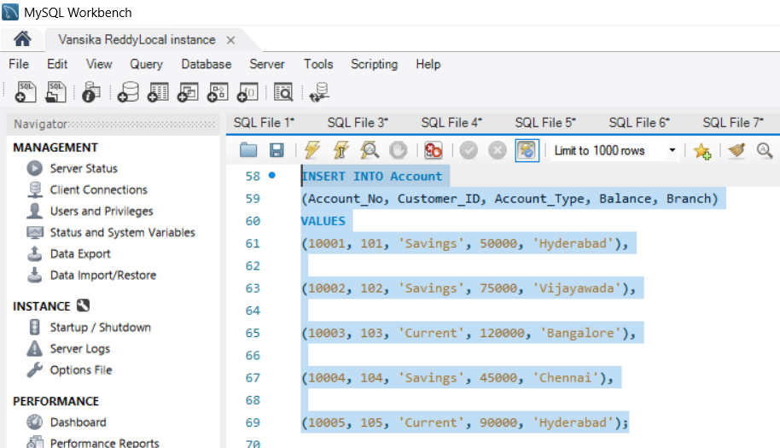

Output:

Query 8: INSERT TRANSACTION DATA
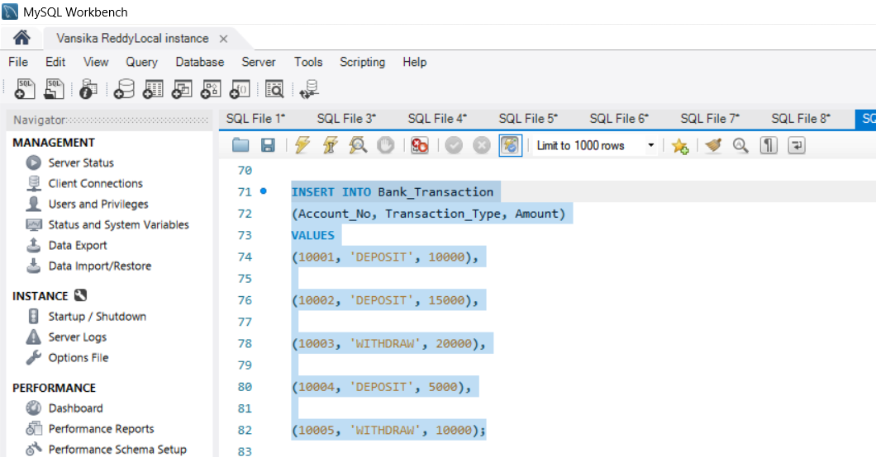

Output:

Query 9: INSERT LOAN DATA
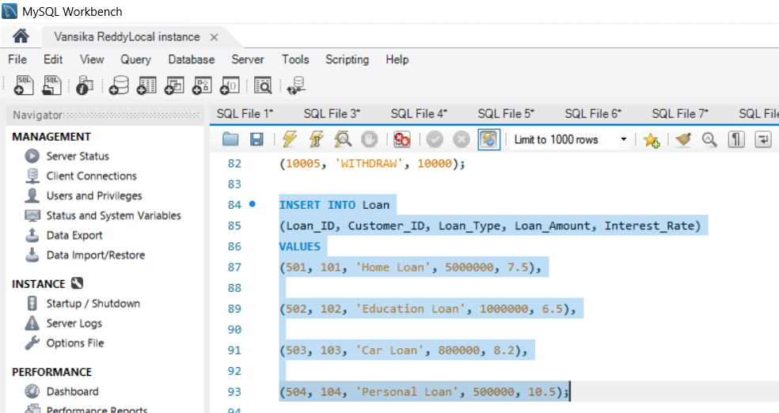

Output:

Query 10: DISPLAY Customer TABLE DATA
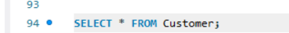
Output:
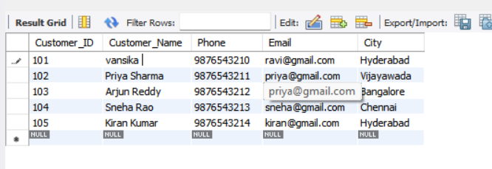

Query 11: DISPLAY Account TABLE DATA

Output:
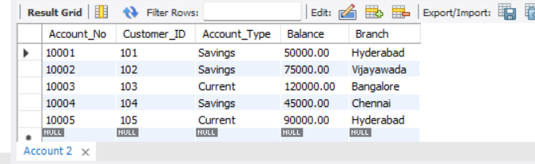
Query 12: DISPLAY Bank_Transaction TABLE DATA:
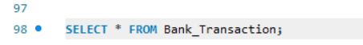
Output:
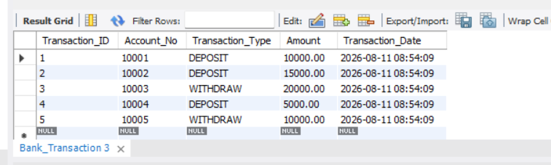
Query 13: DISPLAY Loan TABLE DATA:
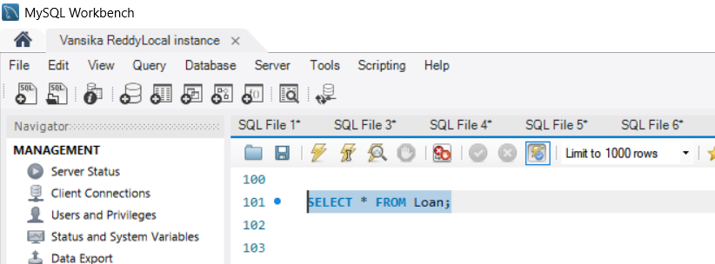

Output:
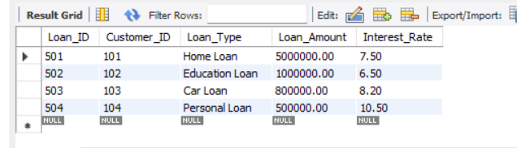

STORED PROCEDURES

Query 14: PROCEDURE TO DISPLAY ALL CUSTOMERS
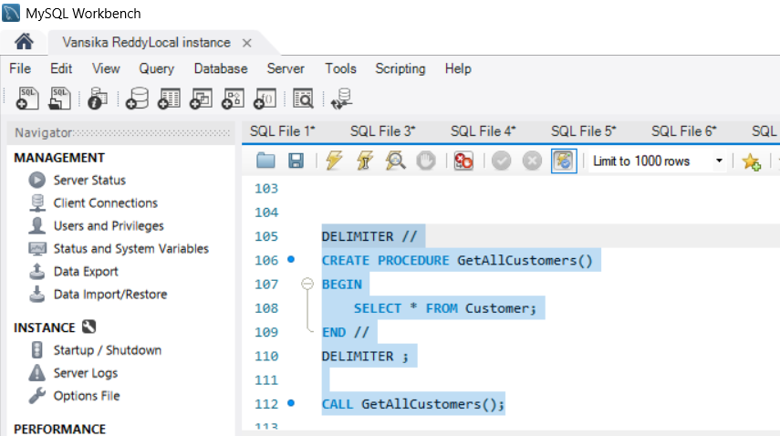

Output:
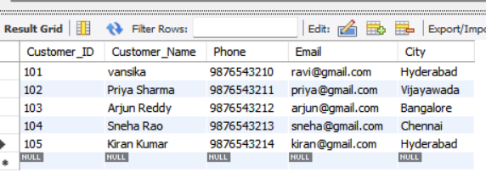

Query 15: PROCEDURE TO DISPLAY ACCOUNT DETAILS
FOR A GIVEN ACCOUNT NUMBER
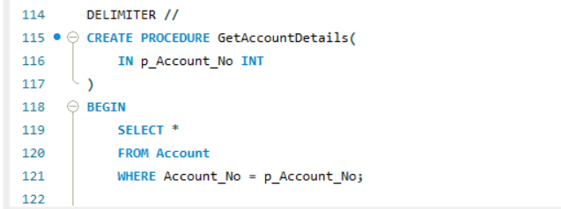
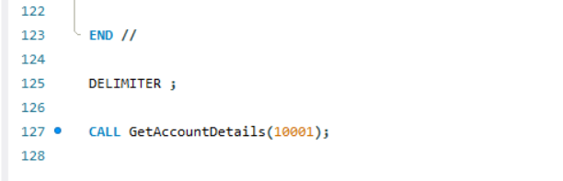
Output:
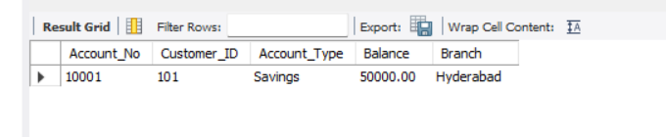
Query 16: PROCEDURE TO FIND CUSTOMER ACCOUNTS
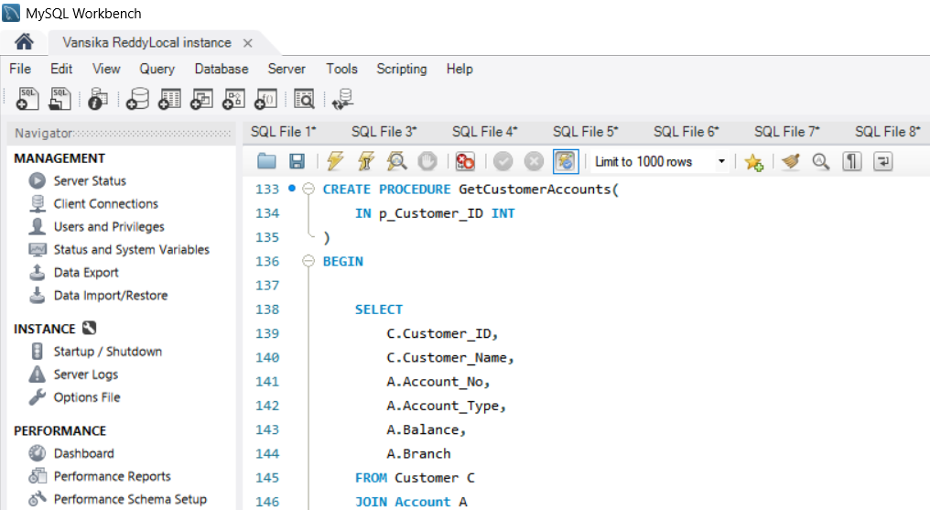

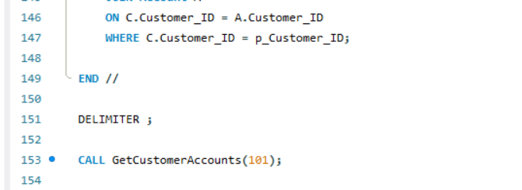
Output:

Query 17: PROCEDURE TO DEPOSIT MONEY
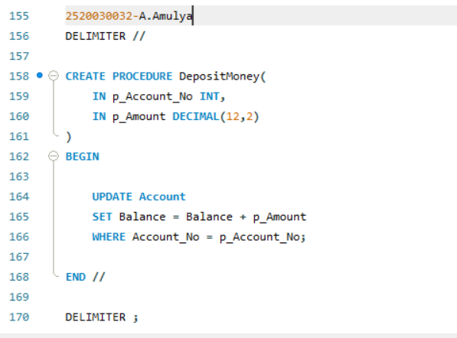

Output:

Query 18: PROCEDURE TO WITHDRAW MONEY
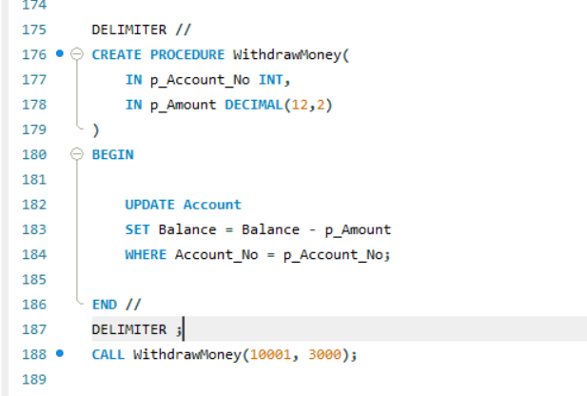
Output:

TRIGGERS
Query 19: TRIGGER – PREVENT NEGATIVE BALANCE
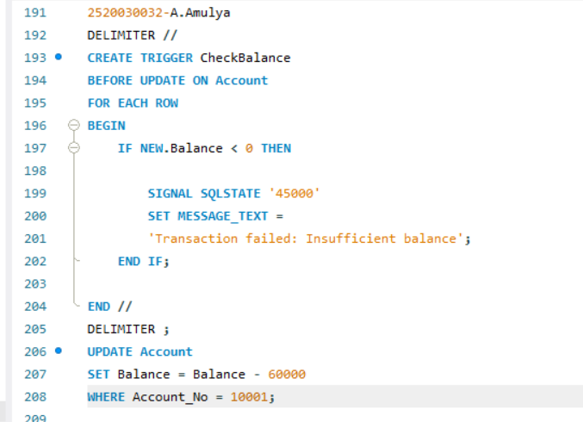
Output:

Query 20: TRIGGER – PREVENT NEGATIVE DEPOSIT
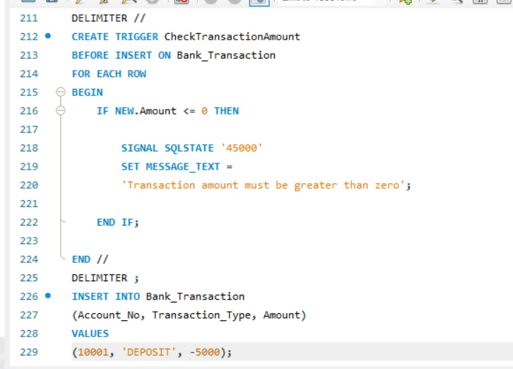
Output:

Query 21: CREATE TRANSACTION AUDIT TABLE
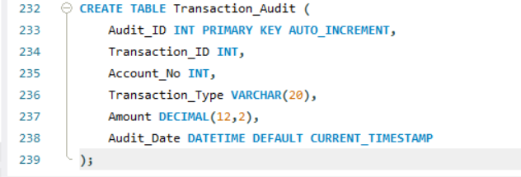
Output:
Query 22: TRIGGER – TRANSACTION AUDIT
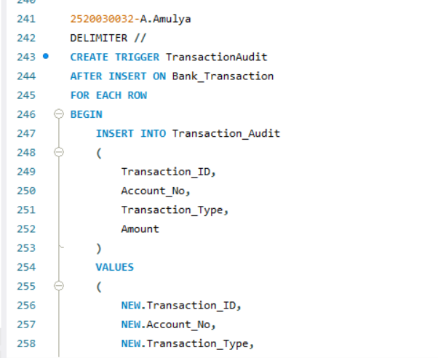
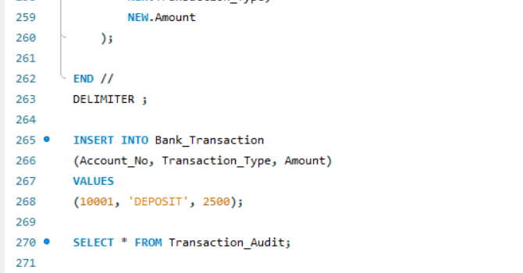
Output:
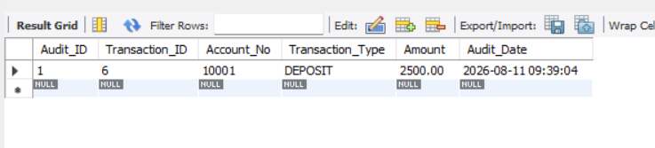
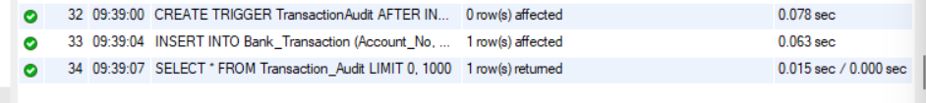

Query 23: TRIGGER – AUTOMATICALLY UPDATE ACCOUNT BALANCE
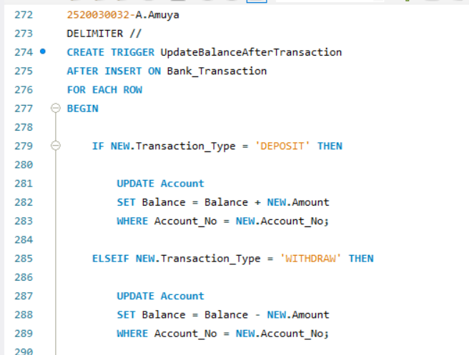
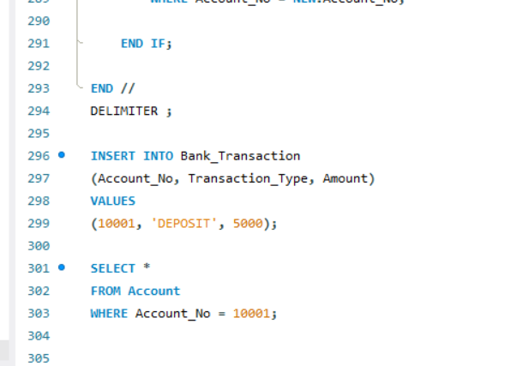
Output:
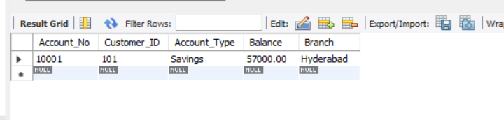
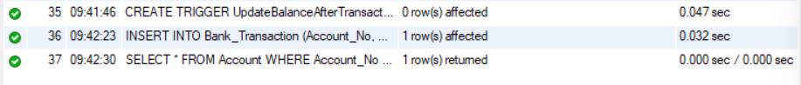

Query 24: TRIGGER – PREVENT WITHDRAWAL ABOVE BALANCE
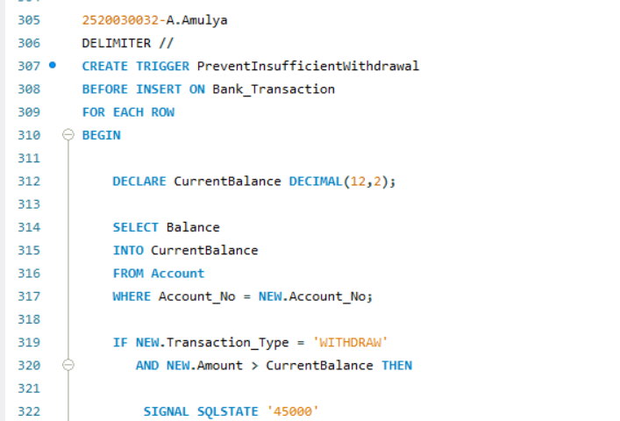
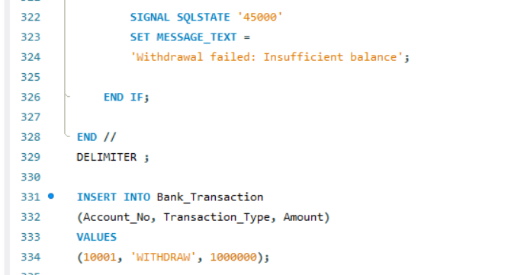
Output:
ADVANCED STORED PROCEDURES

Query 25: PROCEDURE – ACCOUNT TRANSFER
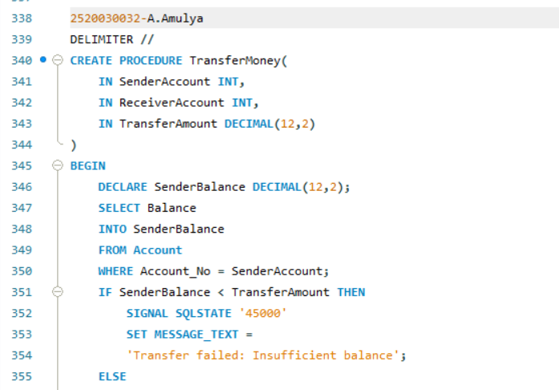
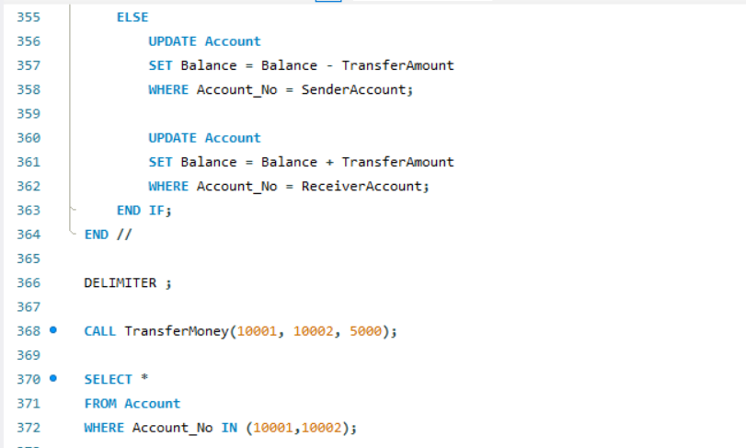
Output:
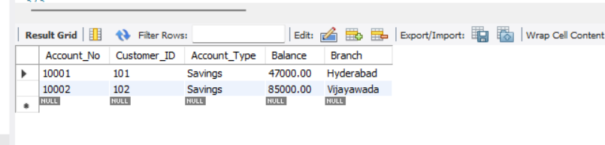
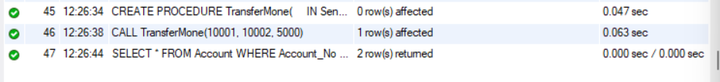

Query 26: PROCEDURE – CUSTOMER LOAN DETAILS
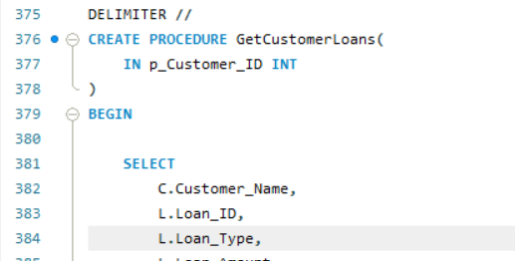
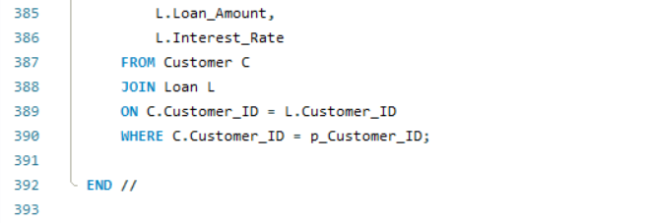
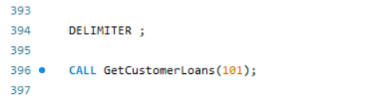
Output:
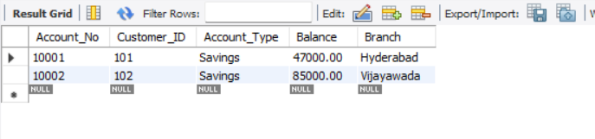

Query 27: PROCEDURE – HIGH BALANCE ACCOUNTS
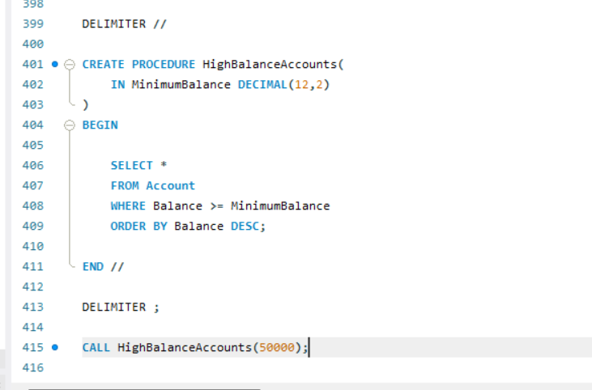
Output:
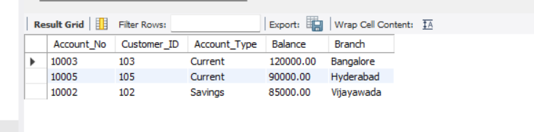
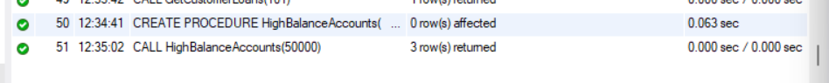

Query 28: PROCEDURE WITH IN, OUT PARAMETERS
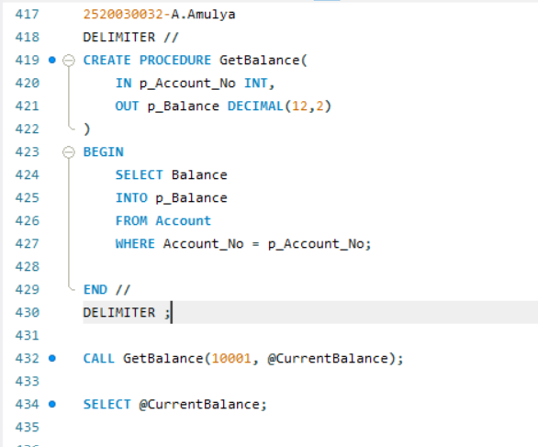
Output:
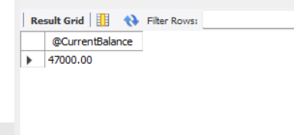
Query 29:
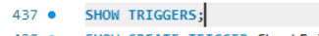
Output:
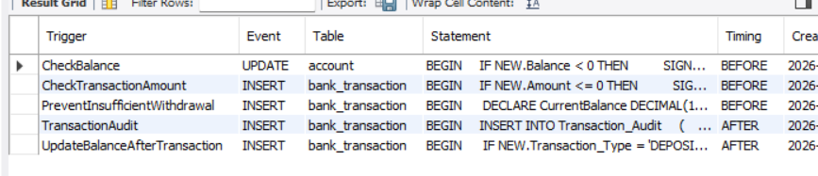
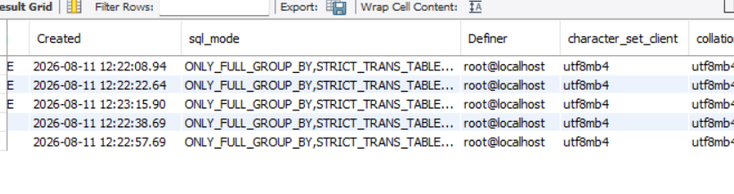
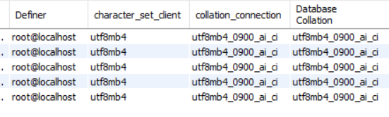
Query 30:
Output:
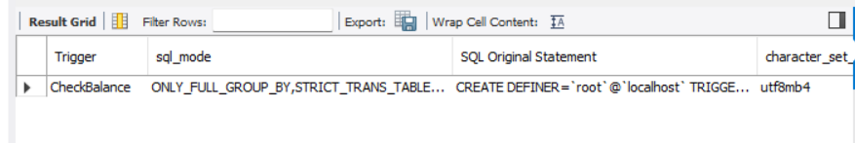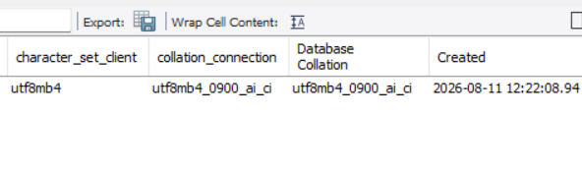
Query 31:
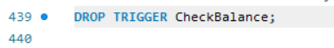
Output:
Query 32: PROCEDURE MANAGEMENT COMMANDS
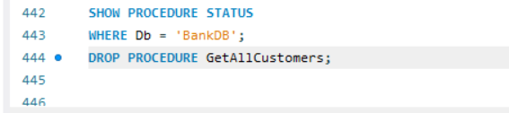
Output:
